NAME:PAREENITA A.SHIRSATH PRN:221101062 ROLL.NO:57 T.E.A.I.&.D.S.

**ML EXPERIMENT NO : 5**

**CODE:**

from google.colab import files

import pandas as pd

import numpy as np

import matplotlib.pyplot as plt

import seaborn as sns

from sklearn.preprocessing import StandardScaler

from sklearn.model_selection import train_test_split

from sklearn.svm import SVC

from sklearn.metrics import classification_report, accuracy_score

# Upload the dataset

uploaded = files.upload()

# Load the dataset

df = pd.read_csv("Mall_Customers.csv")

# Display first few rows

display(df.head())

# Selecting relevant features

X = df[['Annual Income (k$)', 'Spending Score (1-100)']]

# Standardizing the features

scaler = StandardScaler()

X_scaled = scaler.fit_transform(X)

# Creating target variable (Clustering customers into 2 groups for simplicity)

from sklearn.cluster import KMeans

kmeans = KMeans(n_clusters=2, random_state=42)

y = kmeans.fit_predict(X_scaled)

# Splitting data into train and test sets

X_train, X_test, y_train, y_test = train_test_split(X_scaled, y, test_size=0.2, random_state=42)

# Training SVM model

svm_model = SVC(kernel='rbf', random_state=42)

svm_model.fit(X_train, y_train)

# Predictions

y_pred = svm_model.predict(X_test)

# Evaluation

print("Accuracy:", accuracy_score(y_test, y_pred))

print("Classification Report:\n", classification_report(y_test, y_pred))

# Visualization

plt.figure(figsize=(8,6))

sns.scatterplot(x=X_scaled[:, 0], y=X_scaled[:, 1], hue=y, palette='coolwarm')

plt.title("Customer Segmentation using SVM")

plt.xlabel("Annual Income (scaled)")

plt.ylabel("Spending Score (scaled)")

plt.show()

**OUTPUT:**

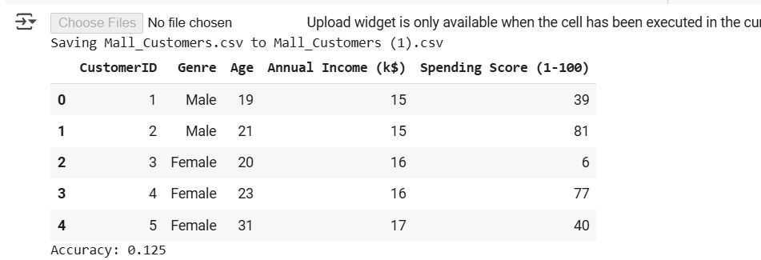

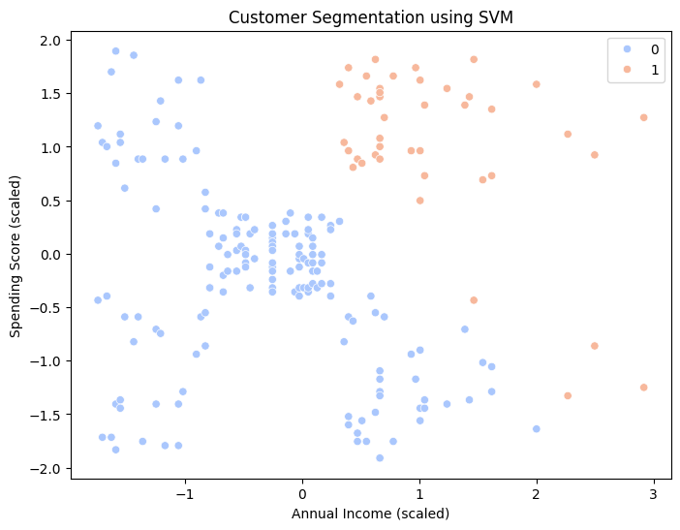

NAME:PAREENITA A.SHIRSATH PRN:221101062 ROLL.NO:57 T.E.A.I.&.D.S.

**ML EXPERIMENT NO : 6**

**CODE:**

from google.colab import files

import pandas as pd

import numpy as np

import matplotlib.pyplot as plt

import seaborn as sns

from sklearn.preprocessing import StandardScaler

from sklearn.model_selection import train_test_split

# Upload the dataset

uploaded = files.upload()

# Load the dataset

df = pd.read_csv("Mall_Customers.csv")

# Display first few rows

display(df.head())

# Selecting relevant features

X = df[['Annual Income (k$)', 'Spending Score (1-100)']]

# Standardizing the features

scaler = StandardScaler()

X_scaled = scaler.fit_transform(X)

# Initializing weights

weights = np.random.rand(X_scaled.shape[1])

bias = np.random.rand()

learning_rate = 0.01

# Hebbian Learning Function

def hebbian_learning(X, y, weights, bias, learning_rate):

    for i in range(len(X)):

        weights += learning_rate * y[i] * X[i]

        bias += learning_rate * y[i]

    return weights, bias

# Creating target variable (Clustering customers into 2 groups for simplicity)

from sklearn.cluster import KMeans

kmeans = KMeans(n_clusters=2, random_state=42)

y = kmeans.fit_predict(X_scaled)

# Splitting data into train and test sets

X_train, X_test, y_train, y_test = train_test_split(X_scaled, y, test_size=0.2, random_state=42)

# Training using Hebbian Learning

weights, bias = hebbian_learning(X_train, y_train, weights, bias, learning_rate)

# Predictions

y_pred = np.sign(np.dot(X_test, weights) + bias)

# Evaluation

accuracy = np.mean(y_pred == y_test)

print("Accuracy:", accuracy)

# Visualization

plt.figure(figsize=(8,6))

sns.scatterplot(x=X_scaled[:, 0], y=X_scaled[:, 1], hue=y, palette='coolwarm')

plt.title("Customer Segmentation using Hebbian Learning")

plt.xlabel("Annual Income (scaled)")

plt.ylabel("Spending Score (scaled)")

plt.show()

**OUTPUT:**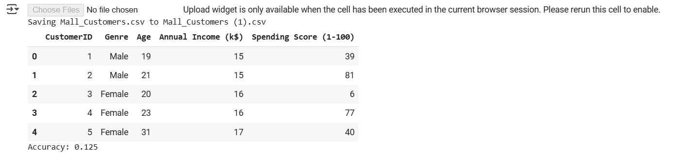

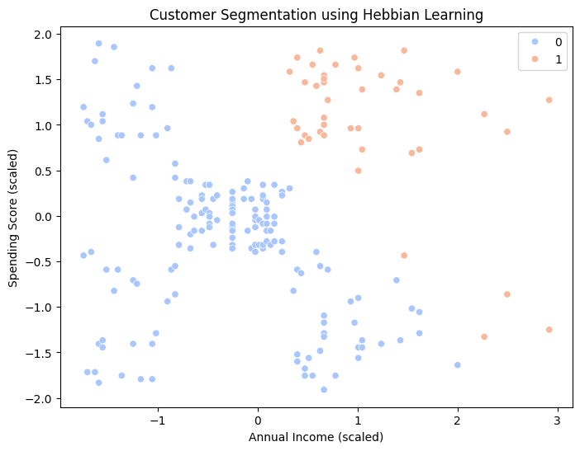

NAME:PAREENITA A.SHIRSATH PRN:221101062 ROLL.NO:57 T.E.A.I.&.D.S.

**ML EXPERIMENT NO : 7**

**CODE:**

from google.colab import files

import pandas as pd

import numpy as np

import matplotlib.pyplot as plt

import seaborn as sns

from sklearn.preprocessing import StandardScaler

from sklearn.model_selection import train_test_split

from sklearn.mixture import GaussianMixture

# Upload the dataset

uploaded = files.upload()

# Load the dataset

df = pd.read_csv("Mall_Customers.csv")

# Display first few rows

display(df.head())

# Selecting relevant features

X = df[['Annual Income (k$)', 'Spending Score (1-100)']]

# Standardizing the features

scaler = StandardScaler()

X_scaled = scaler.fit_transform(X)

# Applying Expectation-Maximization using Gaussian Mixture Model

gmm = GaussianMixture(n_components=2, random_state=42)

gmm.fit(X_scaled)

y_pred = gmm.predict(X_scaled)

# Splitting data into train and test sets

X_train, X_test, y_train, y_test = train_test_split(X_scaled, y_pred, test_size=0.2, random_state=42)

# Evaluation

accuracy = np.mean(gmm.predict(X_test) == y_test)

print("Accuracy:", accuracy)

# Visualization

plt.figure(figsize=(8,6))

sns.scatterplot(x=X_scaled[:, 0], y=X_scaled[:, 1], hue=y_pred, palette='coolwarm')

plt.title("Customer Segmentation using Expectation-Maximization")

plt.xlabel("Annual Income (scaled)")

plt.ylabel("Spending Score (scaled)")

plt.show()

**OUTPUT:** 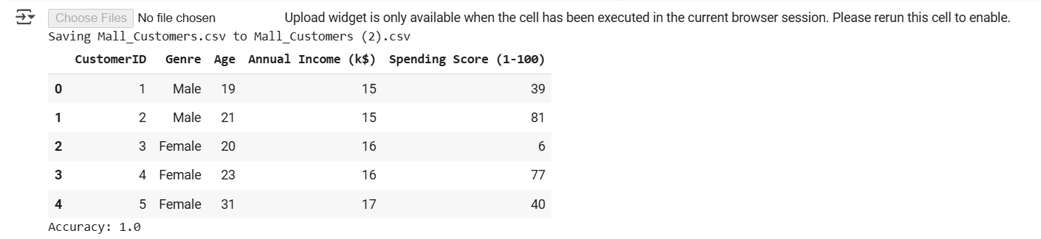

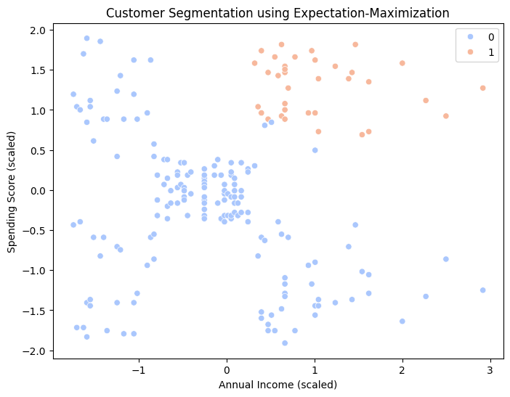

NAME:PAREENITA A.SHIRSATH PRN:221101062 ROLL.NO:57 T.E.A.I.&.D.S.

**ML EXPERIMENT NO : 8**

**CODE:**

from google.colab import files

import pandas as pd

import numpy as np

import matplotlib.pyplot as plt

# Upload the dataset

uploaded = files.upload()

# Load the dataset

df = pd.read_csv("Mall_Customers.csv")

# Display first few rows

display(df.head())

# Selecting relevant features

X = df[['Annual Income (k$)', 'Spending Score (1-100)']]

# McCulloch-Pitts Model Implementation

def mcp_neuron(inputs, weights, threshold):

    weighted_sum = np.dot(inputs, weights)

    return 1 if weighted_sum >= threshold else 0

# Define binary input dataset

X_binary = np.where(X > X.median(), 1, 0)

weights = np.array([1, 1])  # Example weights

threshold = 1  # Example threshold

# Applying McCulloch-Pitts neuron

y_pred = np.array([mcp_neuron(row, weights, threshold) for row in X_binary])

# Removed .values as it's not needed for NumPy arrays

# Display output

print("Predicted Binary Outputs:", y_pred)

# Visualization

plt.figure(figsize=(8,6))

plt.scatter(X['Annual Income (k$)'], X['Spending Score (1-100)'], c=y_pred, cmap='coolwarm')

plt.title("Customer Segmentation using McCulloch-Pitts Model")

plt.xlabel("Annual Income (k$)")

plt.ylabel("Spending Score (1-100)")

plt.show()

**OUTPUT:**

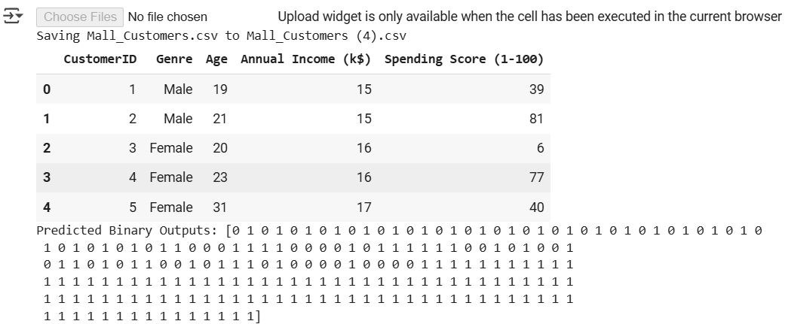

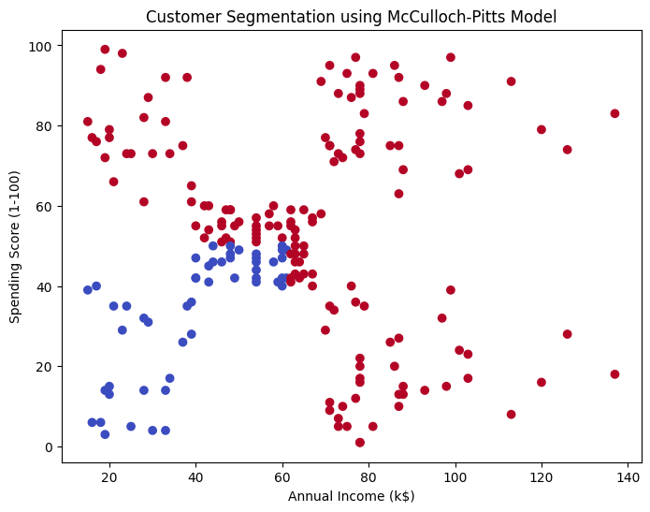

NAME:PAREENITA A.SHIRSATH PRN:221101062 ROLL.NO:57 T.E.A.I.&.D.S.

**ML EXPERIMENT NO : 9**

**CODE:**

from google.colab import files

import pandas as pd

import numpy as np

import matplotlib.pyplot as plt

# Upload the dataset

uploaded = files.upload()

# Load the dataset

df = pd.read_csv("Mall_Customers.csv")

# Display first few rows

display(df.head())

# Selecting relevant features

X = df[['Annual Income (k$)', 'Spending Score (1-100)']]

y = (X['Spending Score (1-100)'] > X['Spending Score (1-100)'].median()).astype(int)  # Binary target

# Standardizing the features

X = (X - X.mean()) / X.std()

# Single Layer Perceptron Implementation

def perceptron_train(X, y, learning_rate=0.01, epochs=100):

    weights = np.zeros(X.shape[1])

    bias = 0

    for _ in range(epochs):

        for i in range(len(y)):

            prediction = np.dot(X.iloc[i], weights) + bias

            y_pred = 1 if prediction >= 0 else 0

            error = y[i] - y_pred

            weights += learning_rate * error * X.iloc[i]

            bias += learning_rate * error

    return weights, bias

# Training perceptron

weights, bias = perceptron_train(X, y)

# Prediction

def perceptron_predict(X, weights, bias):

    return np.where(np.dot(X, weights) + bias >= 0, 1, 0)

y_pred = perceptron_predict(X, weights, bias)

# Display output

print("Predicted Binary Outputs:", y_pred)

# Visualization

plt.figure(figsize=(8,6))

plt.scatter(X['Annual Income (k$)'], X['Spending Score (1-100)'], c=y_pred, cmap='coolwarm')

plt.title("Customer Segmentation using Single Layer Perceptron")

plt.xlabel("Annual Income (standardized)")

plt.ylabel("Spending Score (standardized)")

plt.show()

**OUTPUT:**

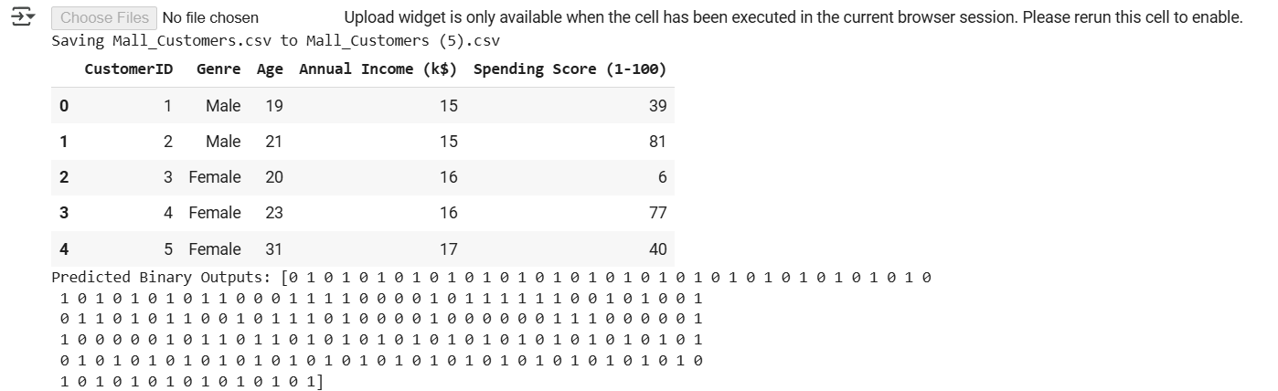

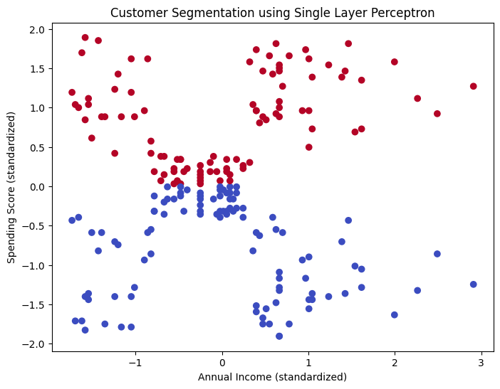

NAME:PAREENITA A.SHIRSATH PRN:221101062 ROLL.NO:57 T.E.A.I.&.D.S.

**ML EXPERIMENT NO : 10**

**CODE:**

from google.colab import files

import pandas as pd

import numpy as np

import matplotlib.pyplot as plt

from sklearn.decomposition import PCA

from sklearn.preprocessing import StandardScaler

# Upload the dataset

uploaded = files.upload()

# Load the dataset

df = pd.read_csv("Mall_Customers.csv")

# Display first few rows

display(df.head())

# Selecting relevant features

X = df[['Annual Income (k$)', 'Spending Score (1-100)']]

# Standardizing the features

scaler = StandardScaler()

X_scaled = scaler.fit_transform(X)

# Applying PCA

pca = PCA(n_components=2)

X_pca = pca.fit_transform(X_scaled)

# Explained variance ratio

print("Explained Variance Ratio:", pca.explained_variance_ratio_)

# Visualization

plt.figure(figsize=(8,6))

plt.scatter(X_pca[:, 0], X_pca[:, 1], c='blue', alpha=0.5)

plt.title("Customer Segmentation using PCA")

plt.xlabel("Principal Component 1")

plt.ylabel("Principal Component 2")

plt.show()

**OUTPUT:**



